Practicum No.2 Date:………….
Secure IoT Data Transmission

- Practical Significance (with respect to practicum no. 1)
In the Internet of Things (IoT) ecosystem, secure data transmission is critical to prevent unauthorized access, data leaks, and privacy breaches. Encryption ensures that sensitive data transmitted between devices is unintelligible to unauthorized users. This practicum enables students to implement data encryption using symmetric (e.g., AES) and asymmetric (e.g., RSA) cryptographic methods within an IoT context. Mastering encryption equips learners to build resilient and trustworthy systems in domains such as healthcare, smart homes, and industrial IoT.

- Competency and Industry-Specific Practical Skills (Kindly copy from the Course Structure)
This practicum exercise is expected to develop the following skills for the industry-identified competency.
- Design and implement secure data communication in IoT applications.
- Apply encryption techniques to ensure secure data transmission in IoT systems. (Cognitive Domain)
- Follow persistence in debugging and circuit testing. (Affective Domain)
- Practice ethical handling of encrypted data. (Affective Domain))

- Relevant CO(s) (Kindly copy from the Course Structure)
CO1. Evaluate smart connectivity technologies and ESP8266-based control systems for IoT applications.

- Practical Outcome (PrO) (Kindly copy from the Course Structure)
- Develop a secure IoT system by applying encryption techniques for data transmission in the given smart environment. [Given during the lab session]

- Related ADO(s) (Kindly copy from the Course Structure)
- Follow ethics while handling data and ensuring data privacy.
- Function independently in analyzing secure transmission techniques.
- Practice secure coding practices for embedded systems.

- Minimum Underpinning Theory (Theory should be written only to relate this practicum)
Data encryption is the process of converting plaintext into ciphertext using cryptographic algorithms to ensure confidentiality. Symmetric encryption (e.g., AES) uses the same key for encryption and decryption, while asymmetric encryption (e.g., RSA) uses a public/private key pair. In IoT, securing communication between devices often involves lightweight cryptographic protocols like TLS/SSL over MQTT or HTTPS. Key management, certificate generation, and cryptographic library integration are crucial topics.
- Practicum Set-up/Circuit Diagram/Algorithm/Flowchart (Copy and paste the probable set-up of the machines)
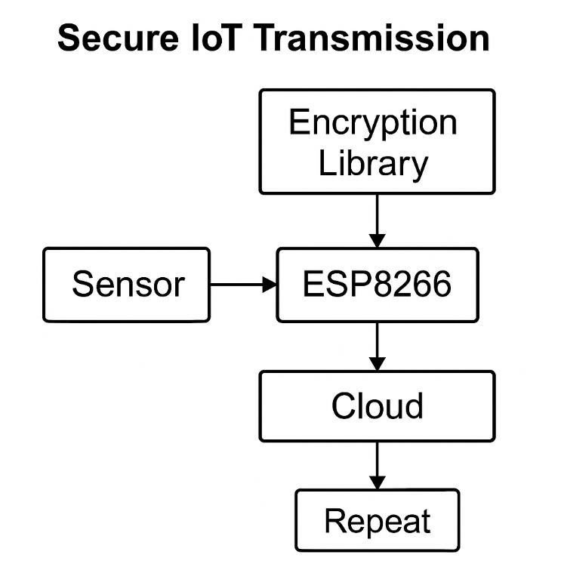

Fig. a. Circuit diagram for secure IoT transmission using ESP8266 and encryption library integration.

- Resources Required

S. No. | Name of Resource | Suggested Broad Specification | Quantity
1 | ESP8266 NodeMCU | Wi-Fi module with encryption support | 1 No.
2 | Sensors (any) | For demo data | 1 No.
3 | Arduino IDE | With Crypto libraries | 1 No.
4 | Serial Monitor/Web UI | Data receiver end | 1 No.
5 | OpenSSL tools | For key generation | 1 No.

- Safety Precautions
- Avoid sharing or exposing private keys.
- Avoid input data to avoid injection attacks.
- Use reliable libraries and trusted sources.

- Procedure
- Install the required cryptographic libraries (e.g., Arduino Cryptography Library).
- Configure ESP8266 to capture sensor input.
- Implement AES or RSA encryption on the transmitted data.
- Set up a receiving interface (web/PC) to decrypt and display data.
- Secure the communication using HTTPS or TLS over MQTT.
- Generate and use secure keys.
- Test for encryption and decryption accuracy.
- Document results.
- Validate integrity and confidentiality.
- Explore alternatives (e.g., ECC) if time permits.

- Actual Resources Used (To be filled by the students)

S. No | Name of Resource | Version/Configuration | Remarks (If any)
 |  |  | -
 |  |  | -
 |  |  | -
 |  |  | -
 |  |  | -

- Actual Procedure Followed (To be filled by the students on the left page)

- Observations (To be filled by the students on the left page if space is not sufficient)

S.No. | Line Number | Syntax Error | Semantic Error | Exceptions
1
2
3

- Results/Observations (To be filled by the students)

- Interpretation of Results (Students to state the meaning of the above-obtained results/observations)
…………………………………………………………………………………………………………………………………….………………………………………………………………………………………...

- Conclusions (Students to draw conclusions (or take decisions) based on the interpretation of results).
……………………………………………………………………………………………………………………………………………………………………………………………………………………………..

- Suggested Practicum Related Questions:
Note: Below given are a few sample questions for reference. Teachers must design more such questions in order to ensure the achievement of pre-determined course outcome.
- What is the difference between AES and RSA in terms of performance?
- Why is encryption essential in IoT systems?
- What is key management and why is it important?
- How does SSL/TLS work in IoT communication?
- What is the advantage of using HTTPS over HTTP?
- How can you verify if the data has been tampered with?
- How does asymmetric encryption ensure security in device pairing?
- What are lightweight encryption algorithms suitable for IoT?
- What is a digital certificate and how is it used?
- What threats can encryption defend against in IoT?

- References / Suggestions for further reading
- https://docs.arduino.cc/libraries/Crypto
- https://randomnerdtutorials.com/esp32-https-requests/
- https://owasp.org/www-project-iot/

- Suggested Assessment Scheme
The given performance indicators should serve as a guideline for assessment regarding process and product-related marks.
Note: The weightage for the process-related skills and product-related skills will change depending upon the PrO, COs, and competency related to the concerned course.

Performance indicators |  | Weightage | Max. Marks | Marks Obtained
Process related: 12 Marks - 40%
 | Code implementation of encryption | 8 % | 2
 | Proper key handling and storage | 17 % | 5
 | Accuracy of encryption/decryption | 8 % | 2
 | Secure communication channel | 7 % | 3
Product related: 18 Marks - 60%
 | Optimized encryption routine | 10 % | 3
 | Handling input/output securely | 10 % | 3
 | Confidentiality of transmission | 10 % | 3
 | Comments and documentation | 06 % | 2
 | Answering viva questions | 18 % | 5
 | Timely submission | 06% | 2
 | Total | 100 % | 30

Names of Student Team Members with Register number:
- …………………………
- …………………………
- …………………………
- …………………………

Marks Obtained |  |  | Dated Signature of Teacher
Process related Skills  (10) | Product related skills (20) | Total  (30)

